CSE 2320 Notes 11: Rooted Trees

(Last updated 11/8/26 1:10 PM)

CLRS 10.4, 12.1-12.3, 14.1, 13.2

11.A. Trees

Representing Trees (main memory, disk devices in CSE 3330)

Binary tree

Mandatory

Left
Right

Optional

Parent
Key
Data
Subtree Size
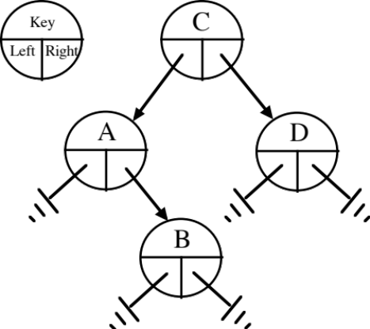

Rooted tree with linked siblings

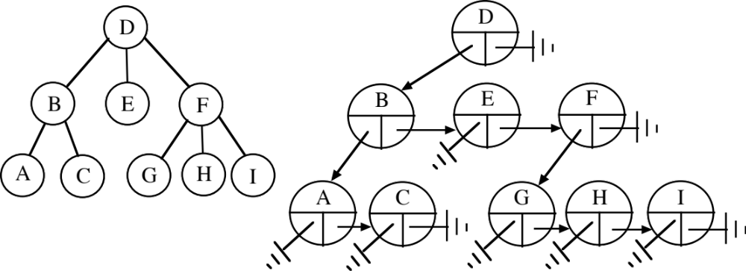

Mandatory Optional

First Child Last Child
Right Sibling Left Sibling
Parent
Key
Data
Subtree Size
11.B. Binary Tree Traversals (review)

1st Visit – Preorder

2nd Visit – Inorder

3rd Visit – Postorder

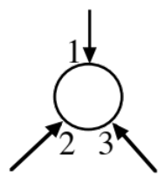

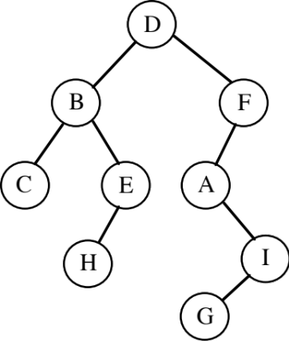
recTraversal(Node h)
{
if (h!=null)
{

recTraversal(h.l);

recTraversal(h.r);

}
}

Preorder

D B C E H F A I G

Inorder

C B H E D A G I F

Postorder

C H E B G I A F D

11.C. Binary Search Trees

Basic property – Go left for smaller keys. Go right for larger keys. (Use of sentinel)

Which traversal lists the keys in ascending order?

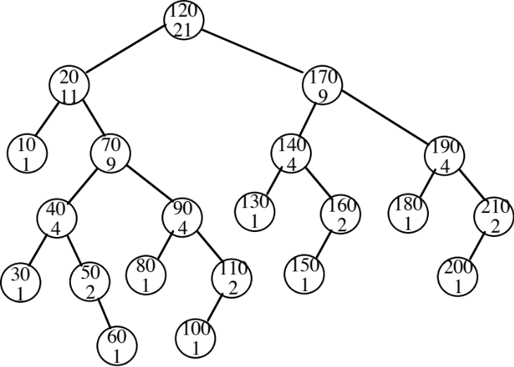

Operations: (see http://ranger.uta.edu/~weems/NOTES2320/REDBLACKC/RB.c )

1. Search (searchR)

2. Minimum / maximum in tree

3. Successor/predecessor of a node

4. Insert (unbalanced in http://ranger.uta.edu/~weems/NOTES2320/REDBLACKC/RB.loadAndGo.c )

5. Deletion of key and associated data is contained in:

a. Leaf

b. Node with one child

c. Node with two children

1. Find node’s successor (convention)

2. Move key and data (but not pointer values) from successor node to node of deletion.

3. Successor has either

a. Zero children – leaf is removed (5.a)

b. One child (right) – point around successor node to remove (5.b)

May also use tombstones and periodically recycle garbage.

Implementing operations 6. and 7. efficiently requires maintaining subtree sizes “incrementally”.

Rank of a key X that appears in tree = number of nodes with keys ≤ X.

Number of nodes on search path to X with keys ≤ key in given node

+

Sizes of their left subtrees

6. Rank of a key (invSelectR).

7. Finds key with a given rank (selectR) - This is the same as flattening tree into an ordered array and then subscripting (or using inorder traversal).

Time for operations?
From http://ranger.uta.edu/~weems/NOTES2320/REDBLACKC/RB.c

int invSelectR(link h, Key v)
// Inverse of selectR
{
Key t = key(h->item);
int work;

if (h==z)
return -1; // v doesn't appear as a key
if (eq(v, t))
return h->l->N+1;
if (less(v, t))
return invSelectR(h->l,v);
work=invSelectR(h->r,v);
if (work==(-1))
return -1; // v doesn't appear as a key
return 1 + h->l->N + work;
}

int STinvSelect(Key v)
{
return invSelectR(head,v);
}

Item selectR(link h, int i)
// Returns the ith smallest key where i=1 returns the smallest
// key. Thus, this is like flattening the tree inorder into an array
// and applying i as a subscript.
{
int r = h->l->N+1;

if (h == z)
{
printf("Impossible situation in selectR\n");
STprintTree();
exit(0);
}
if (i==r)
return h->item;
if (i<r)
return selectR(h->l, i);
return selectR(h->r, i-r);
}

Item STselect(int k)
{
if (k<1 || k>head->N)
{
printf("Range error in STselect() k %d N %d\n",k,head->N);
exit(0);
}
return selectR(head, k);
}

11.D. Rotations

Technique for rebalancing in balanced binary search tree schemes. Takes Θ(1) time.

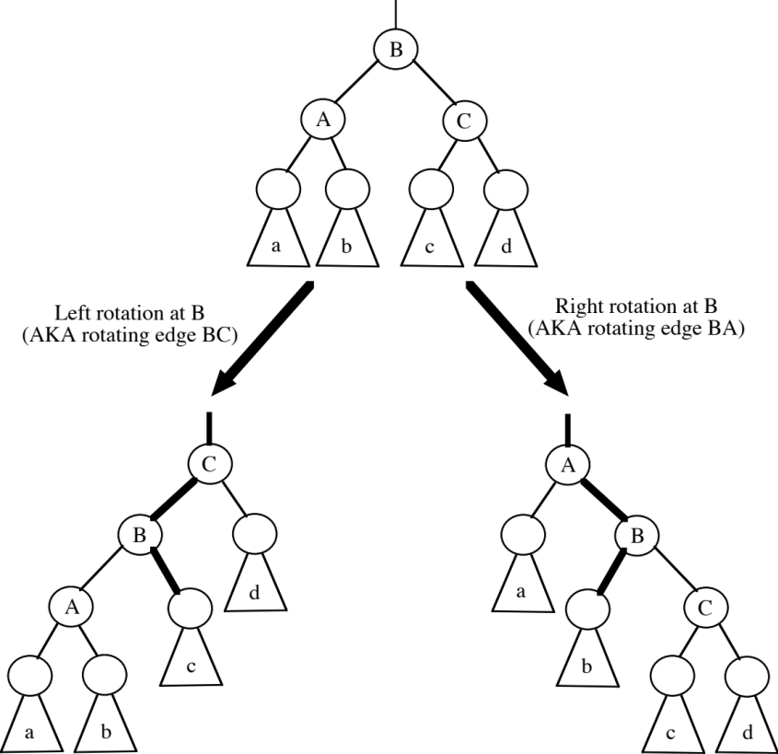

11.E. Insertion at Root: rotates all edges on the insertion path:

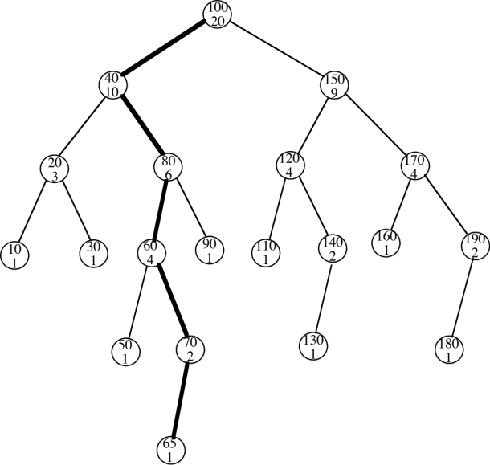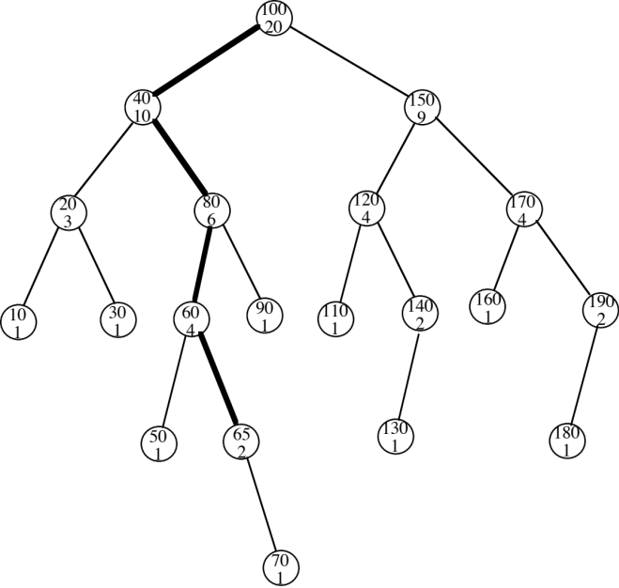

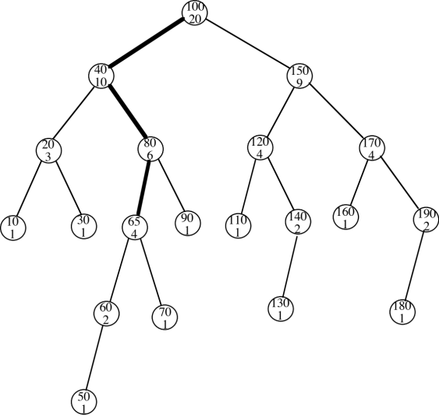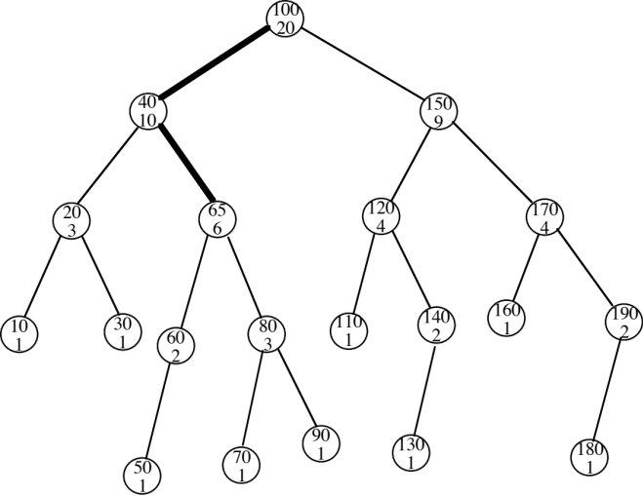

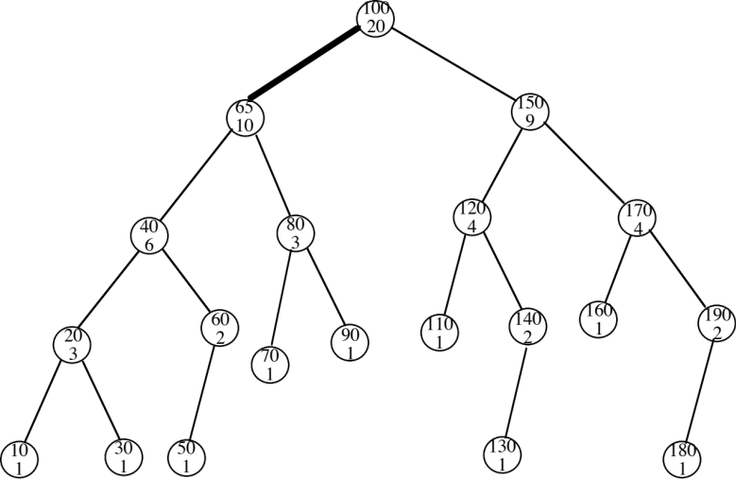

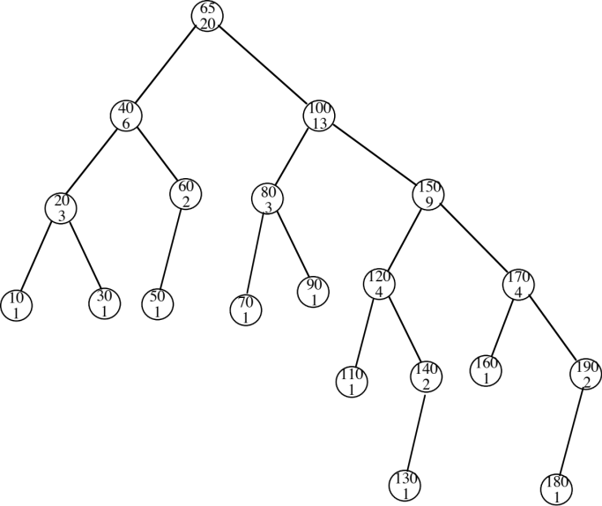

http://ranger.uta.edu/~weems/NOTES2320/bst.step.html

